BREAK and continue STATEMENT

The break statement in Python is used to terminate the execution of the nearest enclosing loop (either a for loop or a while loop). When the break statement is encountered inside a loop, the loop is immediately terminated, and the program control proceeds to the first statement following the loop.

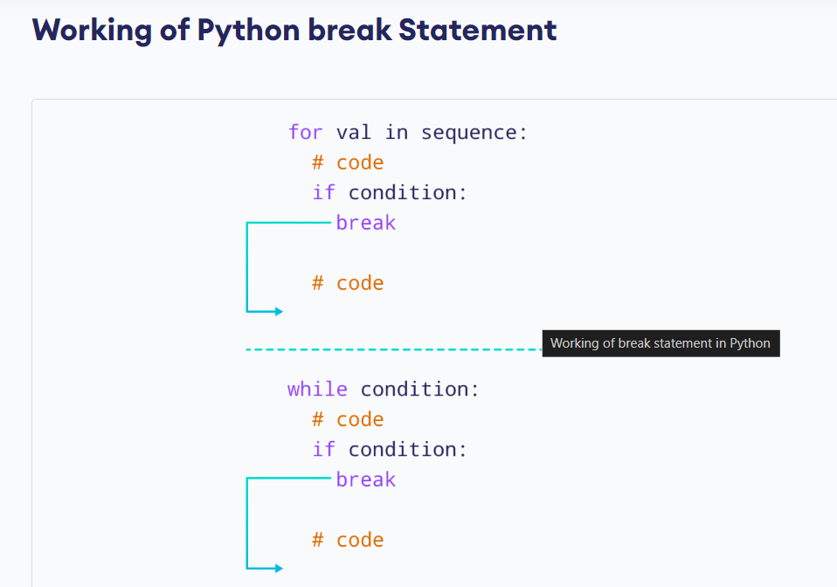

Example:- example of continue statement.

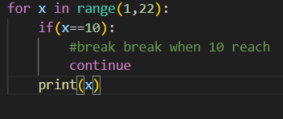

Output:-

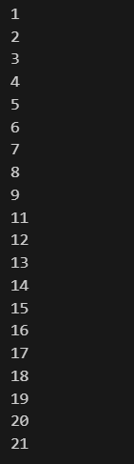

Example:- example of break statement.

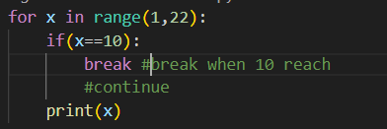

Output:-

